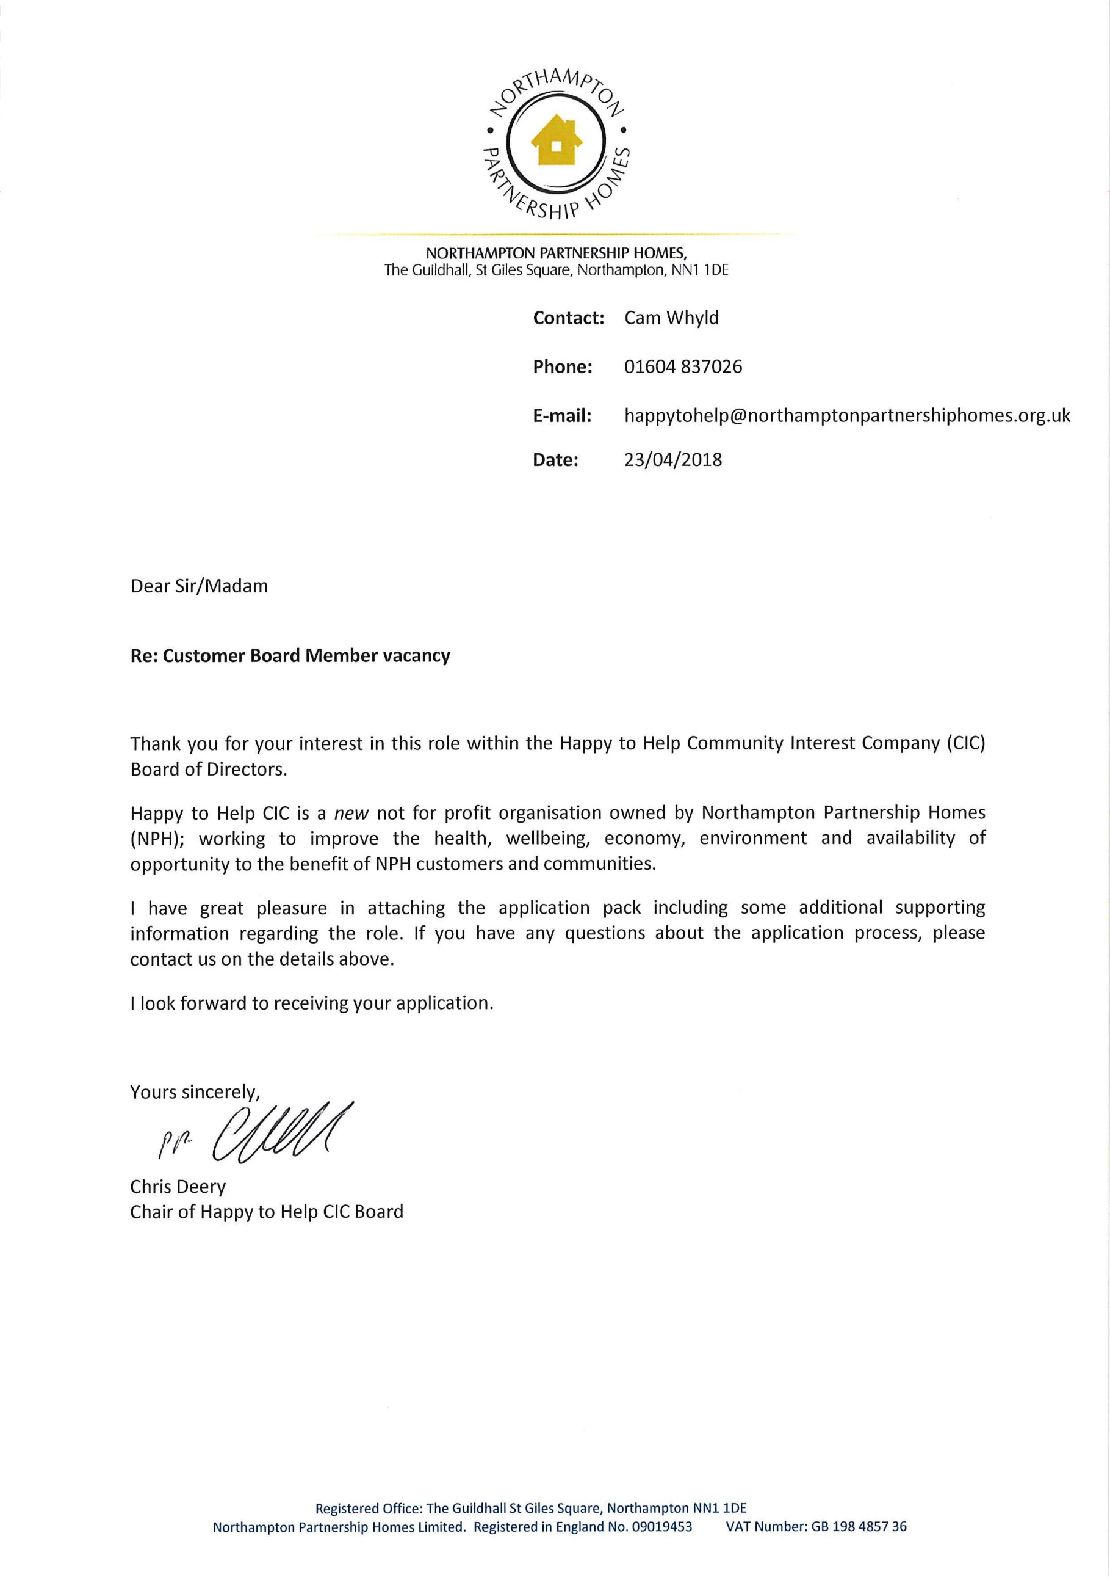
Happy to Help Community Interest Company
Customer Board Member Role Description

The appointment process and expected timescales for the recruitment of a Customer Board Member is as follows:

Midday 11 May 2018 | The deadline for receiving your application. Both parts 1 and 2 of the application form need to be received by this date.

w/c 21 May 2018 | The Recruitment Panel will assess all application forms received.  Following this process, feedback will be given to advise whether or not you have been shortlisted.  Shortlisted candidates will be invited to interview.

Monday 04 June 2018 | Interviews take place  (Please ensure you are available on this date).

w/c 11 June 2018 | Feedback will be given as to whether or not candidates are successful.

Friday 19 October 2018 | The NPH Board will formally appoint the successful Customer Board Member at the 2018 Annual General Meeting.

Happy to Help Community Interest Company
Customer Board Member Role Description
Title: | Customer Board Member
Responsible to: | Chair of Happy to Help CIC
Responsible for
- Act in the capacity of a Director under company legislation and within the powers and remit vested in the CIC by Northampton Partnership Homes (NPH)
- Ensure the necessary financial, risk and performance management systems are in place to deliver efficient, effective, value for money services that meet customer needs and priorities
- Adhere to the vision, mission, values and culture of NPH
- Direct, control and scrutinise company affairs, ensuring compliance with the CIC’s Community Interest Statement and strategic objectives, ensuring its long-term success
Remuneration | Out of pocket expenses will be paid
Term of Office | A period of 3 years and subject to re-election, up to a maximum of 9 years in total in office
Main areas of responsibility and specific duties
Strategic Direction, Leadership and Compliance
- Provide strategic leadership for the direction, oversight and control of the CIC
- Ensure that the Company is governed correctly in line with its constitutional, statutory and regulatory obligations, its Code of Conduct, legislation and best practice, and that the Company acts within its powers
- Ensure all Board decisions comply with the Companies Act 2006
- Contribute to and share responsibility for the CIC Board’s decisions, including its duty to exercise reasonable care, skill, diligence and independent judgement
- Set, monitor and review the short and long term objectives, strategy and performance of the CIC
- Show understanding of the external factors which influence the work of the CIC, such as: Government policy, welfare reform, changes within society and the economy, the changing needs of Northampton and its communities
- Foster a culture which enhances commitment, enthusiasm and excellence and of working together to achieve success
Financial Management and Control of Risk
- Approve and monitor budgets for income and expenditure and seek to identify and manage risk at all times
- Maintain financial control by approving and monitoring the corporate plan, the accounts, cash flow, and any grant monies obtained
- Establish and oversee a risk management framework in order to safeguard the assets and reputation of the CIC
- Contribute to the review and evaluation of present and future strengths, weaknesses, opportunities and threats in both the internal and external environment, to support the development of an effective, forward looking organisation

Governance
- Oversee and review a framework of delegation and systems of internal control
- Ensure that the CIC meets it legal and statutory obligations
- Ensure all decisions reflect a commitment to and compliance with Equality & Diversity and Health and Safety legislation
- Adopt safe working practices

Foster Positive and Effective Working Relationships
- Ensure effective working relationships are developed with other Board Members, NPH staff and Board, external partners and stakeholders in the interests of delivering the objectives of the CIC and in meeting the needs of customers
- Ensure that the CIC actively engages with customers to identify and to meet their aspirations and contributes to the development of the local communities and the neighbourhoods in which customers live
- Ensure that the CIC, as a subsidiary, works closely with NPH, as the ‘parent’ organisation
- Represent the CIC when requested

Operation of the Board
- Work with other Board members as a team to ensure that the Board operates effectively
- Apply specialist skills, knowledge, experience, and perspectives in Board meetings to contribute and share responsibility for the Board’s decisions including its duty to exercise reasonable care, skill and independent judgement
- Attend Board meetings and, where required, task and finish groups
- Be fully prepared for and take an active role in Board meetings, task and finish groups and other events
- Fully participate in learning and development relevant to the role of a Board Member
- Participate in reviews of your own individual performance as a member of the Board and that of the Board as a whole
- Respect confidentiality of information
- Lead by example at all times, maintaining the highest standards of probity
- Participate in the recruitment and selection of future Board Members as and when required
- Declare any relevant interests and act in accordance with the requirements of the constitution in relation to those interests

Time Commitment
All Board members should be able to allocate sufficient time to the CIC to discharge their responsibilities effectively.
The frequency of meetings may vary. Board will meet approximately every two months in the evening. Meetings are expected to last up to two hours. Board Members are also expected to allow adequate time to prepare for meetings so they are able to contribute and participate fully in discussion.
Board members may also be asked to be involved in any task and finish groups that are established or others as appropriate. There will also be opportunities for direct involvement in delivery of CIC projects.
There will be induction training, followed by regular training and information for Board members to aid understanding, update and refresh their skills and knowledge in relation to their role and responsibilities. Training may be delivered collectively and/or to individual members. Training may last between 1 to 2 hours, or possibly to take the form of occasional full day or half day sessions.
Expenses
Board Members will not be paid for their time but are entitled to claim reimbursement of actual expenses incurred when undertaking official duties such as attending Board Meetings. All payments will be made in line with the Board Expenses Policy.

The Customer Board Member Person Specification is designed to give applicants an idea of the range and type of experience, skills and personal values/qualities which are considered to be relevant for them be appointed to the CIC’s Board.
Essential Experience:
A tenant or leaseholder and receiving housing management services from the Northampton Partnership Homes

Demonstrate an understanding of the issues, concerns and priorities of people living in areas where NPH manage housing

Essential Skills:
Listening, communicating and getting on with others

Manage time effectively, to be able to identify and to focus on key issues and priorities

Ability to think at an overall strategic level and not get lost in the detail

Ability to make informed decisions and exercise clear judgement

Work as a team and share responsibility

Essential Values. To show commitment and contribute to:
Being passionate and positive about bringing improvements to communities

Acting in the best interests of the Company

Observing and complying with the Board Code of Conduct

Uphold high standards of governance

Providing services that offer value for money

Respecting confidentiality of information

The development of your own skills and knowledge

Attending & taking an active part in Board meetings

Upholding the principles of Equality & Diversity

Customer Board Member Application Reference No

Happy to Help Community Interest Company
Customer Board Member

Part 1 Customer Board Member Application

Information about you, your eligibility to apply to be a Customer Board Member and Equalities Monitoring Information

About You
Preferred Title:
First name:
Last name:
Address:
Post code:
Contact numbers: | Daytime: |  | Evening:
 | Mobile:
E-mail address:

Declaration of Eligibility to Become a Customer Board Member
There are certain criteria which must be met in order for you to be eligible for board membership in accordance with the Companies Act 2006 and Happy to Help CIC Articles of Association. There are certain people who cannot be, or might not be suitable to be, Members of the Board.

This is to make sure that Board appointments do not hinder the effective operation of the Board or damage the reputation of the company, as well as meeting certain legal requirements under the Companies Act 2006.

Please read the following page of criteria carefully and place a tick against each of the declarations, providing additional information where requested. Happy to Help CIC will need to verify the information that you have provided.

Declaration | Tick to show you agree with the statement
I am either the principle or joint tenant named on the tenancy agreement or licence (if aged between 16 - 18 years)
I am not in breach of my tenancy agreement or licence and I am not subject to any enforcement action by the Council e.g. Notice Seeking Possession for rent arrears, noise nuisance or action for non-payment of council tax. If you have declared that you are a tenant who is in breach of your tenancy agreement/licence please give details on a separate sheet
I am not currently buying my home under the Right to Buy
I am 16 years of age, or older
I am not a Councillor
I am not employed by Northampton Partnership Homes
I am not an undischarged bankrupt
I am not currently subject to a bankruptcy restriction order or undertaking made by the court
I am not subject to a disqualification order made by the court or I have not given disqualification undertakings
I am not prohibited by law from becoming a company director
I have not made a composition arrangement with my creditors which is not being complied with
I am not disqualified from elected membership of a local authority
I am not in the opinion of a registered medical practitioner who is treating me (and who gives written notice to NPH confirming such opinion), physically or mentally incapable of acting as a director and may remain so for more than three months

Overall Declaration
Please read the following statement carefully and if you wish to proceed, sign and date this application form.

- I declare that, to the best of my knowledge, the information contained in this application form is true and correct. I have read and understood the supporting documentation included with this application.

- If appointed, I am prepared to comply with any relevant rules and obligations and to act in good faith and in the interests of Happy to Help CIC.

- I understand that if the Board reasonably believes that the behaviour of one of its Members is such to bring the Board or company into disrepute, action may be taken to remove/exclude that person from the Board.

- I know that Board Members are volunteers and are not entitled to receive payment (other than properly incurred expenses which will be reimbursed in line with the Board Expenses Policy).

- I acknowledge that Happy to Help CIC will conduct any searches and checks necessary to verify this information. I understand that if I don’t want these checks to go ahead my application will not be progressed.

Signature: | Date:

Please return your application form (both Parts 1 and 2) to:

happytohelp@northamptonpartnershiphomes.org.uk

Or post to:
FAO Happy to Help CIC
Northampton Partnership Homes
Westbridge Depot
9-13 St James Mill Road
Northampton
NN5 5JW

The closing date for applications is midday 11 May 2018

Thank you

Equalities Monitoring Declaration Form
This section will be detached from the application form prior to short listing.
The information you provide will be used for monitoring and statistical data purposes only, and will NOT be seen by the short listing panel.
We are committed to ensuring that applicants are selected on the basis of their abilities relevant to the job.
Completion of this section will help us to ensure that our policy and procedures are effective in avoiding discrimination and promoting equal opportunities in recruitment.

Monitoring Equality and Diversity
Age:

Gender:
What is your sexual orientation?

What is your marital status?

If you selected 'Other' please give further details

Ethnic Origin: I would describe my ethnic origin as:

What is your religion?

If you selected 'Other' please give further details

Are your day-to-day activities limited because of a health problem or disability which has lasted or is expected to last at least 12 months?

Under the Equality Act 2010 a disability is defined as “A physical or mental impairment that has a substantial and long term adverse effect on a person’s ability to carry out normal day to day activities”

Customer Board Member Application Reference No

Happy to Help Community Interest Company
Customer Board Member

Part 2 - Statement to Support Your Customer Board Member Application

About Your Experience, Skills and Personal Qualities

Please refer to the Happy to Help CIC Customer Board Member Role Description and Person Specification, which are both included in your information pack to help you answer the following questions.

Wherever possible, include details about the experience, skills and personal qualities that you have in relation to the requirements we have stated are relevant in a Customer Board Member.

Please answer on no more than one A4 side per question. If your submission is being typed, please use size 12 font.

Please ensure you have completed both Parts 1 and 2 of your application and return both parts to:
happytohelp@northamptonpartnershiphomes.org.uk

Or post to:
FAO Happy to Help CIC
Northampton Partnership Homes
Westbridge Depot
9-13 St James Mill Road
Northampton
NN5 5JW

The closing date for applications is midday 11 May 2018.

Thank you
- Please tell us about the skills you have which you can bring to this role

- What do you see your role as a customer board member being?

- What do you believe you will bring to the role as a customer board member?

- Please provide examples of your experience of working as part of a group, including how your contribution helped and how decisions were reached

- What is your vision for the future of Happy to Help CIC?

